
Department of Computer Engineering and Technology
MINI PROJECT REPORT
Computer Networks Laboratory
(CSE20110)
Laboratory Continuous Assessment 3

Anchor: Design and Implementation of a Custom Reliable Transport Protocol over UDP

Submitted by
Sr. No. | Student Name | PRN
1 | Aditya Rawat | 1262242230
2 | Chaitanya Datar | 1262242226
3 | Shivam Masalkar | 1262242320
4 | Archit Deshpande | 1032231994

Group No. 20 Panel K - ios Batch 1 and 2
Third Year B.Tech. Computer Engineering and Technology
Under the guidance of
Dr. Uma Pujeri
Academic Year 2026–2027
Submission Date : 21-Oct-2026
Department of Computer Engineering and Technology
CERTIFICATE

This is to certify that the mini-project entitled “Anchor: Design and Implementation of a Custom Reliable Transport Protocol over UDP” has been carried out by the following students of Third Year B.Tech. Computer Science and Engineering, Panel K-ios, Batch 1 and 2, Group No. 20, under my guidance during the academic year 2026–2027.
Student Name | PRN
Aditya Rawat | 1262242230
Chaitanya Datar | 1262242226
Shivam Masalkar | 1262242320
Archit deshpande | 1032231994

The report is submitted towards the mini-project component of Laboratory Continuous Assessment 3 for the Computer Networks Laboratory course.

Faculty Signature __________________________
Dr. Uma Pujeri
Project Guide and Course Faculty
Date ____________________ Place: Pune

Acknowledgement
The project team acknowledges the support provided by the Department of Computer Engineering and Technology at MIT World Peace University for the Computer Networks Laboratory mini-project. The project was developed using Java networking APIs and the supplied development and testing resources. The project documentation and implementation were reviewed against the code and the manual baseline transfer performed for this report.
Group No. 20

Abstract
Anchor is a Java-based educational implementation of a reliable file-transfer protocol built on UDP. Because UDP does not guarantee delivery, ordering, or duplicate suppression, Anchor adds a custom reliability layer with session setup, acknowledgements, selective retransmission, receiver-side reassembly, and transfer-completion handling. The recorded Windows PowerShell baseline transferred a 697-byte file successfully and reported matching source and received SHA-256 digests, with zero DATA retransmissions. This result demonstrates the basic end-to-end path; it is not a performance benchmark.
Keywords: UDP reliability, Selective Repeat ARQ, Java socket programming, file integrity

Table of Contents

1 Introduction and Project Objectives
2 Proposed Design and Requirements
2.4 Comparison of TCP, UDP, and Anchor
3 Implementation and Technical Working
3.4 Java Source Files and Packet Header
3.5 Execution Procedure
4 Testing and Results
5 Discussion and Conclusion
5.2 Insights Gained
References
AI Usage Declaration

List of Figures
Figure 2.1 Anchor client–server architecture and UDP message flow
Figure 3.1 Anchor protocol message sequence
Figure 3.2 Client protocol state machine
Figure 3.3 Server receiver state machine
Figure 4.1 Windows PowerShell baseline transfer and SHA-256 verification

List of Tables
Table 1.1 Project objectives and verification methods
Table 2.1 Tools and system requirements
Table 2.2 Addressing and protocol configuration
Table 4.1 Test plan and observed results
Table 4.2 Objective achievement

1 Introduction and Project Objectives

1.1 Introduction and Background
Transport-layer protocols enable applications on different hosts to communicate. UDP, specified in RFC 768, provides a connectionless datagram service with low protocol overhead, but it does not guarantee delivery, ordering, or retransmission [1]. Applications that require these properties must implement them at the application layer or use a transport protocol that already provides them. RFC 8085 also highlights the need for UDP applications to consider congestion, message size, fragmentation, and network behaviour [2].
Anchor explores these concepts by implementing a reliability layer over UDP datagrams. The client sends file chunks identified by sequence numbers; the server acknowledges received chunks and buffers out-of-order data until it can reconstruct the file. Selective Repeat ARQ allows individual unacknowledged packets to be retransmitted instead of resending an entire window. Java’s DatagramSocket and DatagramPacket classes provide the socket interface [3]. A custom binary codec defines the packet format, CRC-32 checks packet consistency, and SHA-256 compares the completed source and destination files. These mechanisms are intended for education and do not provide encryption, peer authentication, or production-grade congestion control.

1.2 Problem Statement
UDP does not guarantee that a datagram will arrive, arrive only once, or arrive in order. A file-transfer application that sends chunks directly over UDP can therefore produce an incomplete or incorrectly ordered destination file when packets or acknowledgements are lost, duplicated, delayed, or corrupted. Anchor addresses this problem by implementing a custom protocol that detects and recovers from selected transmission failures while continuing to use UDP as its underlying transport.

1.3 Scope
Anchor is intended for computer-networking education and controlled demonstrations of transport-layer reliability. It provides a Java client and server that can run as separate processes on one computer or on two computers connected through a LAN. The client sends a local file to the server over a configured UDP port, and the receiver stores the reconstructed file in the downloads directory. Configurable loss and delay simulation support repeatable experiments. Anchor is not a replacement for TCP and does not claim encryption, authentication, or production-grade congestion control. The results discussed in this report are limited to the evidence explicitly recorded in Section 4.

1.4 Objectives
The project objectives below are linked to implemented features and to the evidence available for this report. The recorded baseline demonstrates a successful local transfer and file-integrity match; broader reliability and performance claims require repeatable test evidence.
Objective ID | Objective | Verification Method
O1 | Implement a custom UDP file-transfer protocol with session setup. | Manual client–server baseline; protocol source review.
O2 | Recover from loss, duplicates and out-of-order delivery. | Verified by the JUnit 5 suite: tests for simulated loss, duplication, reordering, delay, corruption detection, retransmission, and receiver reassembly all passed.
O3 | Verify end-to-end file integrity and report metrics. | Verified by the manual baseline SHA-256 comparison and the passing JUnit integrity-digest and file-transfer tests.

2 Proposed Design and Requirements

2.1 Architecture and Network Topology
Anchor follows a client–server architecture. The client reads a source file, divides it into chunks, encodes protocol packets, and sends the packets as UDP datagrams to the server address and port. The server validates incoming datagrams, tracks sequence numbers, acknowledges received data, buffers out-of-order chunks, and writes the reconstructed file to the downloads directory. At session completion, the server reports the result and integrity information.
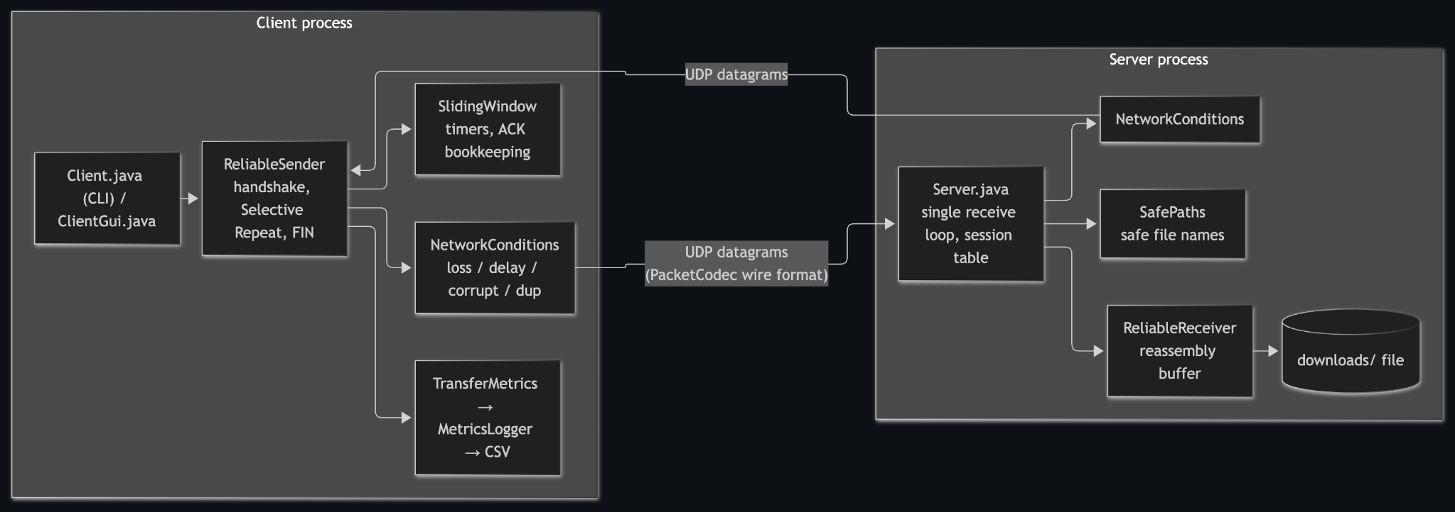
Figure 2.1 Anchor client–server architecture and UDP message flow
Client → Server: UDP datagrams (SYN, DATA, FIN)
Server → Client: UDP datagrams (SYN_ACK, ACK, FIN_ACK, ERROR)
Client components: file reader, sliding window, timers, retransmissions, and metrics
Server components: packet validation, acknowledgement generation, reassembly, safe file output, and integrity reporting

2.2 Tools and System Requirements
The implementation is written in Java and uses standard Java networking, input/output, checksum, hashing, and logging APIs. The project requires JDK 17 or newer. The supplied Windows PowerShell screenshot documents a successful local baseline transfer. The JUnit 5 console output supplied for this report records 70 tests found and started, all 70 successful, zero failures, zero skipped or aborted tests, and 11 successful test containers; the run completed in 9.711 seconds. The test suite covers transfer integration, server behaviour, simulated network conditions, sliding-window mechanics, receiver reassembly, packet encoding and validation, utilities, and failure handling.
Tool or Resource | Version or Specification | Purpose
Java Development Kit | OpenJDK 21 used for baseline; Java 17+ required | Compile and run client/server.

2.3 Addressing and Protocol Selection
Anchor is a socket-programming project rather than a static network-device configuration. In the recorded baseline run, the client and server ran on the same computer using loopback address 127.0.0.1 and UDP port 5000. For a two-computer demonstration, the client must target the server computer’s LAN IP address, and the selected UDP port must be allowed by the host firewall. The packet format is documented in docs/PROTOCOL.md.
Device / Interface | IP / Prefix | Gateway | Role
Client and server host | 127.0.0.1 (baseline) | Not applicable (loopback) | Client sends; server receives

UDP was selected because the project demonstrates how selected reliability functions can be implemented above an unreliable transport. Each packet uses a 22-byte big-endian header containing the version, packet type, receive window, session identifier, sequence number, acknowledgement number, payload length, and CRC-32. Supported packet types are SYN, SYN_ACK, DATA, ACK, FIN, FIN_ACK, and ERROR. The sender uses a sliding window and timeout handling for Selective Repeat. The receiver acknowledges duplicate packets without writing the same chunk twice and buffers out-of-order chunks for ordered reassembly. CRC-32 detects packet corruption; SHA-256 is used to compare completed files and is not an encryption or authentication mechanism.

2.4 Comparison of TCP, UDP, and Anchor
TCP and UDP are standard transport-layer protocols; Anchor is an application-defined reliability protocol implemented over UDP. Anchor does not combine TCP and UDP sockets or switch between them. It sends UDP datagrams and implements selected reliability mechanisms—session setup, sequence numbers, acknowledgements, timers, selective retransmission, reassembly, and transfer verification—inside the application. This makes Anchor a teaching implementation of how reliability can be built above an unreliable datagram service.
Feature | TCP | UDP | Anchor
Connection model | Connection-oriented; connection setup before data | Connectionless datagrams | Custom SYN/SYN_ACK session handshake carried in UDP
Delivery guarantee | Reliable, ordered byte stream with retransmission | No built-in delivery guarantee | Acknowledgements and timeout-based retransmission for file chunks
Ordering | Application receives an ordered byte stream | Datagrams may be lost or reordered | Sequence numbers and receiver buffering reassemble chunks in order
Duplicate handling | Handled by TCP transport | No built-in duplicate suppression | Duplicate DATA is recognized and not written twice
Error detection | TCP checksum | UDP checksum (IPv4 optional; IPv6 required) | CRC-32 validates packets; SHA-256 compares reconstructed file with source
Flow / congestion control | Built-in receiver flow and congestion control | No built-in flow or congestion control | Advertised receive window provides flow control; not TCP-equivalent congestion control
Typical use | Web, SSH, email, database sessions, reliable streams | DNS, real-time media, games, telemetry | Educational file transfer and controlled experiments with loss/delay
Important distinction: Anchor’s CRC-32 detects accidental packet corruption; SHA-256 compares file contents at the end of a transfer. Neither encrypts data or authenticates the sender. Anchor is not a production replacement for TCP because it does not provide TCP’s complete congestion-control, security, and interoperability behaviour.

3 Implementation and Technical Working

3.1 Methodology
The implementation is organised into protocol encoding, transport logic, socket endpoints, and supporting utilities. Packet and PacketCodec define and validate the wire format. SlidingWindow, ReliableSender, and ReliableReceiver manage the transmission window, acknowledgements, timeout retransmission, duplicate handling, and ordered reassembly. Client and Server provide the independent UDP endpoints. NetworkConditions supports configurable impairment simulation; TransferMetrics and MetricsLogger record transfer measurements; and FileChecksum computes SHA-256 digests. The normal workflow is to build the project, start the server, launch the client with a source file, establish a session, transmit and acknowledge DATA packets, complete the FIN/FIN_ACK exchange, and compare the file digests.
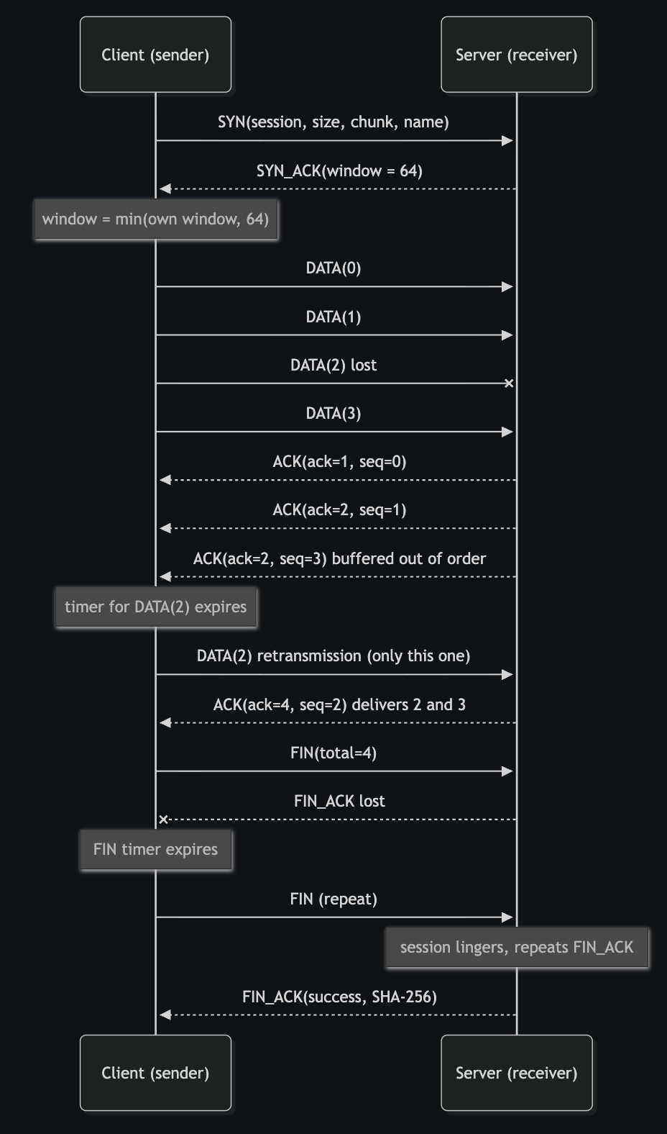
Figure 3.1 Anchor protocol message sequence, including selective retransmission and session termination
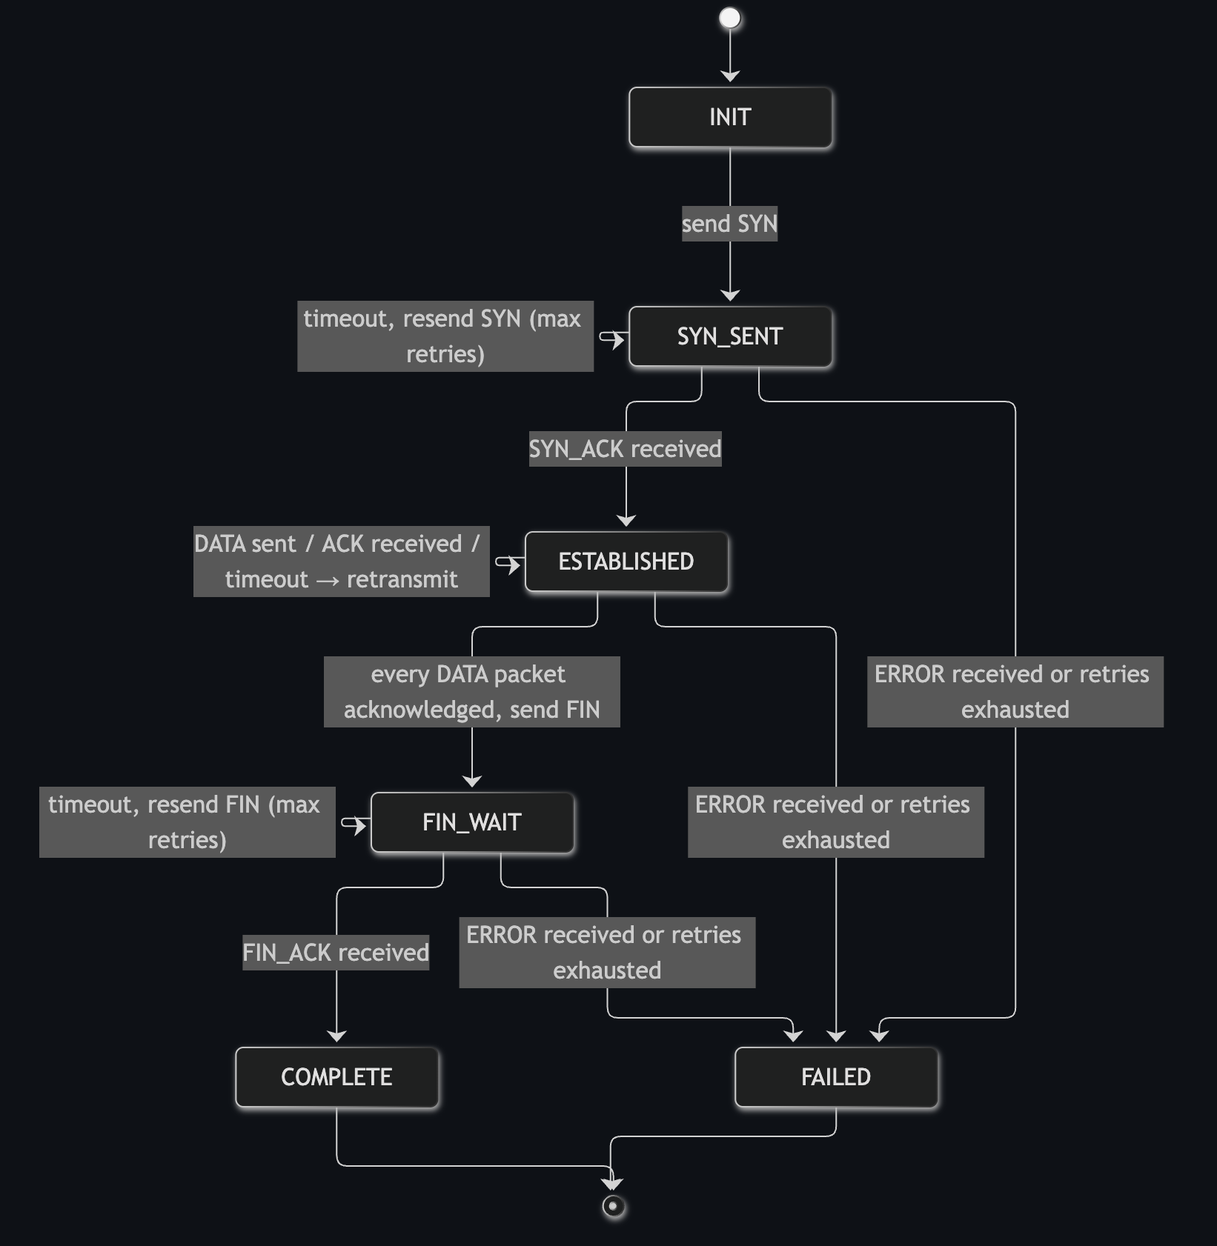
Figure 3.2 Client protocol state machine
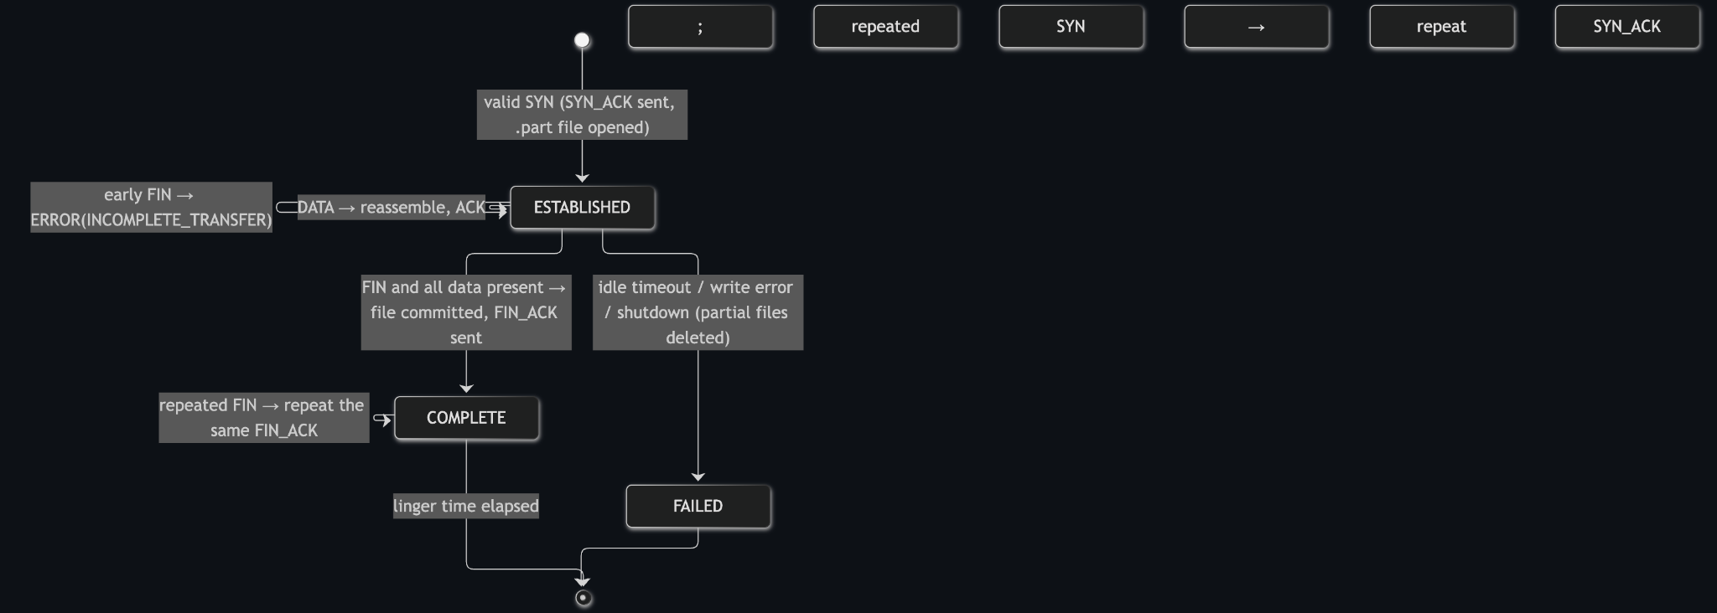
Figure 3.3 Server receiver state machine

3.2 Configuration or Code Implementation
The main entry points are Client.java and Server.java. Protocol data structures and encoding are implemented in protocol/Packet.java, PacketType.java, PacketCodec.java, and ProtocolConfig.java. Reliability logic is implemented in transport/ReliableSender.java, ReliableReceiver.java, SlidingWindow.java, and TransferSession.java. Network impairment simulation is provided by simulation/NetworkConditions.java; metrics are recorded by metrics/TransferMetrics.java and MetricsLogger.java; and SHA-256 support is provided by util/FileChecksum.java. Repository defaults include a 1024-byte chunk, a sender window of 16 packets, a 200 ms timeout, a maximum of 10 retries, and a server receive window of 64 packets. Command-line options can override supported settings.

3.3 Protocols and Technical Working
The client begins by sending SYN with the session identifier and file metadata. The server responds with SYN_ACK and its receive-window capacity. DATA packets carry file chunks and sequence numbers. The server validates the packet version, type, length, and CRC-32 before processing each packet. ACK packets report acknowledgement state. The sender retransmits unacknowledged packets after their timers expire, subject to the configured retry limit. The receiver buffers out-of-order chunks and writes them in sequence. FIN signals that the sender has finished transmitting; FIN_ACK returns the final status and integrity information. ERROR packets communicate invalid requests or transfer failures. The server’s completion-linger behaviour allows it to respond again if the final acknowledgement is lost.

3.4 Java Source Files and Packet Header
Java does not use separate C/C++-style header files (.h). In this project, declarations are organized into .java source files, while package declarations and import statements identify namespaces and dependencies. Public classes and interfaces provide declared APIs, but Java compiles source files rather than including header files. The main source files and their responsibilities are summarized below.
Representative imports used by the Java implementation include java.net.DatagramSocket and java.net.DatagramPacket for UDP communication; java.net.InetAddress and java.net.InetSocketAddress for endpoint addressing; java.nio.ByteBuffer for binary packet fields; java.nio.charset.StandardCharsets for text encoding; java.util.Arrays for byte-array handling; and java.util.zip.CRC32 for packet checksum calculation. These imports are declarations inside .java files, not separate header files.
Java source file / package | Responsibility
reliableudp/Client.java | Client entry point; parses arguments, opens a DatagramSocket, invokes ReliableSender, and reports results.
reliableudp/Server.java | Server entry point; receives UDP datagrams and coordinates transfer sessions.
protocol/Packet.java and PacketType.java | Represent protocol packets and message types: SYN, SYN_ACK, DATA, ACK, FIN, FIN_ACK, ERROR.
protocol/PacketCodec.java | Encodes/decodes the binary wire format; validates version, type, length, and CRC-32.
transport/ReliableSender.java and SlidingWindow.java | Manage send window, ACK tracking, timers, and selective retransmissions.
transport/ReliableReceiver.java and TransferSession.java | Track receive state, buffer out-of-order chunks, and reassemble the file.
simulation/NetworkConditions.java | Optionally simulates loss, delay, jitter, corruption, and duplication.
util/FileChecksum.java; metrics/* | Calculate SHA-256 and record transfer statistics to CSV.
The custom packet header is 22 bytes long and uses big-endian (network byte order). The payload follows the header. CRC-32 covers header bytes 0–17 and the payload; the checksum field occupies bytes 18–21.
Byte offset | Size | Field | Purpose
0 | 1 byte | Version | Protocol version; currently 1.
1 | 1 byte | Type | Packet type code, such as DATA or ACK.
2 | 2 bytes | Window | Receiver’s available slots; meaningful in SYN_ACK and ACK.
4 | 4 bytes | Session ID | Identifies the transfer session.
8 | 4 bytes | Sequence number | Identifies a DATA chunk or control-message position.
12 | 4 bytes | Acknowledgement number | Reports cumulative receive progress.
16 | 2 bytes | Payload length | Must equal datagram length minus the 22-byte header.
18 | 4 bytes | CRC-32 | Detects accidental corruption in selected header bytes and payload.
22 onward | Variable | Payload | File chunk or control metadata, depending on packet type.

3.5 Execution Procedure
Prerequisites
Install JDK 17 or newer, open a terminal or command prompt, and extract the Anchor project. Confirm that the project root contains the scripts directory and the Java source files.
NOTE : all the IP Addresses used in the examples are taken at random any overlap with existing system is just a coincidence
Step 1: Open the project directory
Open a terminal or command prompt and change to the project root directory—the directory that contains the scripts folder.
Step 2: Build the project
Compile the Java source code with the build script for your operating system.
Windows build command:
scripts\build.bat
Linux/macOS build command:
bash scripts/build.sh
Step 3: Start the server
In Terminal 1, navigate to the project root and start the server on UDP port 5000.
Server command (Linux/macOS):
java -cp out/main reliableudp.Server 5000
Server command (Windows):
java -cp out\main reliableudp.Server 5000
Step 4: Start the client
In Terminal 2, navigate to the same project root and run the client with the file to be transferred. The example below sends sample.txt to a server running on the same computer.
Client command (Linux/macOS):
java -cp out/main reliableudp.Client localhost 5000 sample.txt
Client command (Windows):
java -cp out\main reliableudp.Client localhost 5000 sample.txt
Step 5: Run across two computers (optional)
For a LAN transfer, start the server on the receiving computer, identify its LAN IP address, and allow UDP port 5000 through the relevant firewall. On the sending computer, replace localhost with the server’s actual LAN IP address.
Example LAN client command:
java -cp out/main reliableudp.Client 192.168.1.10 5000 sample.txt
Step 6: Configure optional client parameters
Optional client flags include --chunk (data chunk size), --window (transmission window size), --timeout (acknowledgement timeout), --retries (retry limit), --loss (simulated packet loss), --delay (artificial delay), and --verbose (detailed output). Use the exact syntax documented by the application’s command-line help or project instructions.
Step 7: Verify the received file
After the transfer finishes, locate the received file in the downloads directory. Compare the source and received files; matching SHA-256 digests indicate that the file contents match for this transfer.
Step 8: Review transfer statistics
If the application writes transfer statistics, review logs/transfers.csv for the recorded transfer details.
Baseline execution evidence
The supplied Windows PowerShell screenshot records a successful transfer of output.txt (697 bytes). The client reports zero DATA retransmissions and matching source and received SHA-256 digests; the server reports that the session completed. This is evidence for the displayed local baseline only.

4 Testing and Results

4.1 Test Plan
The test plan combines the manual Windows PowerShell baseline transfer with the automated JUnit 5 test suite. The baseline uses loopback address 127.0.0.1 and UDP port 5000 to transfer output.txt (697 bytes). The supplied JUnit summary records 70 successful tests across 11 successful containers, with no failures, skips, or aborts. Scenarios include large and empty files, simulated loss and delay, packet reordering and duplication, corrupted or malformed datagrams, retransmission limits, session handling, safe file paths, and SHA-256 integrity reporting.
Test ID | Test and Input | Expected Result | Observed Result | Status
T1 | Baseline local transfer | File transfer completes and source/received SHA-256 digests match. | SUCCESS; output.txt (697 bytes); 1 unique DATA packet; 0 retransmissions; 0 timeouts; digest MATCH. | PASS
T2 | Simulated packet loss | Transfer recovers and file integrity remains correct. | PASS; automated integration tests for 5% and 10% simulated loss, combined loss and delay, and recovery scenarios passed. | PASS
T3 | Delay, corruption, or reordering | Transfer completes correctly or reports a clear failure; no silent corruption. | PASS; automated tests covering artificial delay, jitter/reordering, duplicate packets, corruption detection, and recovery passed. | PASS
T4 | JUnit 5 automated test suite (11 containers) | All included tests complete without failures. | 70 tests successful; 0 failed, skipped, or aborted; 11 containers successful; 9.711 seconds. | PASS

4.2 Results and Execution Evidence
The manual baseline completed successfully for output.txt (697 bytes), with one unique DATA packet, zero DATA retransmissions, zero timeouts, and Integrity: MATCH. In addition, the supplied JUnit 5 console output reports 70/70 tests successful, 0 failed, 0 skipped, and 0 aborted across 11 successful test containers. The recorded automated run took 9.711 seconds. These results support the tested protocol behaviours; they do not replace further performance measurements on physical multi-host networks.
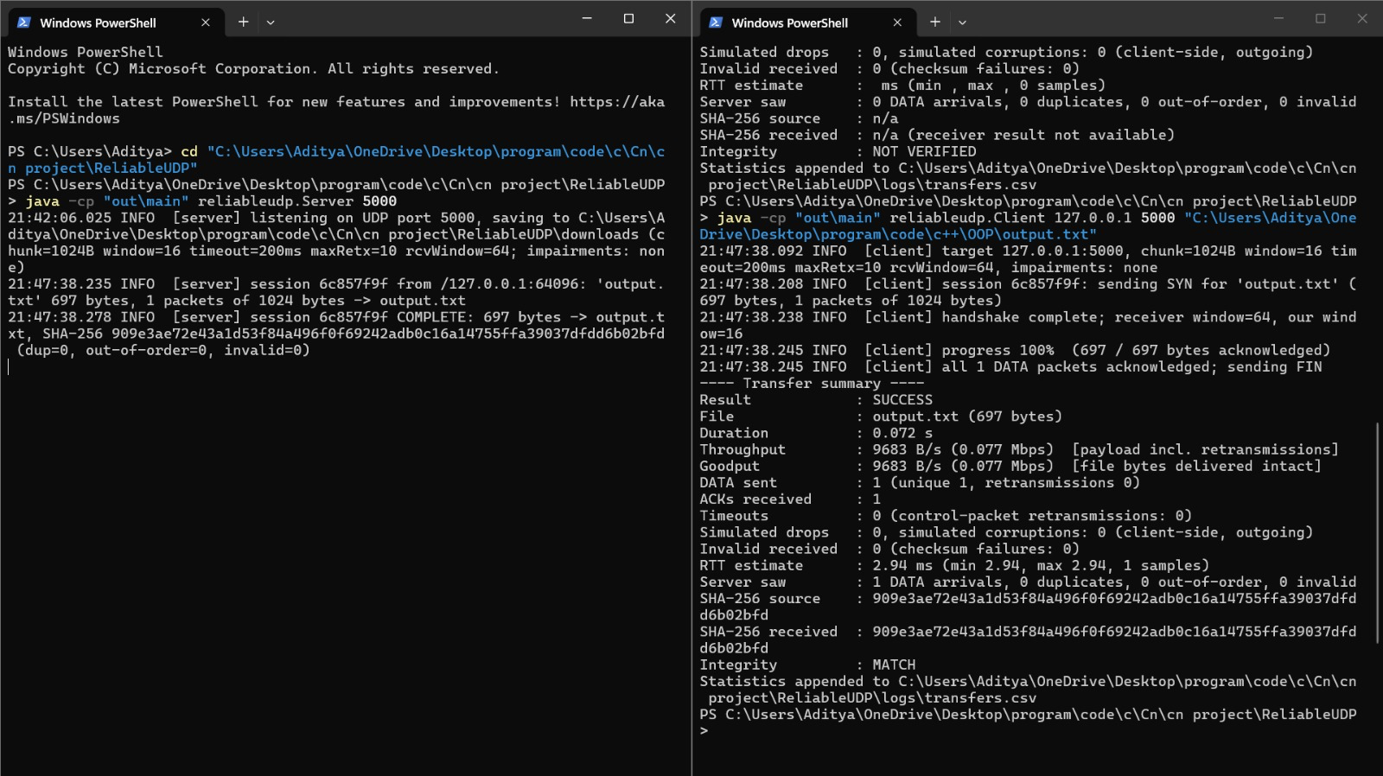
Figure 4.1 Windows PowerShell baseline transfer and SHA-256 verification
Baseline result: SUCCESS; file: output.txt (697 bytes); DATA packets: 1 unique, 0 retransmissions; timeouts: 0; integrity: MATCH. The source and received SHA-256 digests match.

4.3 Objective Achievement
The objectives are supported by both the manual baseline and automated test evidence. The baseline demonstrates a successful local client–server transfer and matching source/received SHA-256 digests. The JUnit suite passed all 70 tests, including cases for loss, delay, duplication, reordering, packet corruption and validation, sliding-window acknowledgements, receiver reassembly, retransmission limits, and failure handling. Multi-host LAN performance and wide-area network behaviour remain outside the evidence supplied here.
Objective ID | Evidence or Test ID | Outcome
O1 | Baseline transfer and source-code review; 70/70 automated tests passed. | Demonstrated by the successful baseline and passing automated tests for transfer setup and protocol behaviour.
O2 | Automated loss, delay, duplication, reordering, corruption, sliding-window, and retransmission tests. | Supported by passing tests covering the listed reliability scenarios.
O3 | Baseline SHA-256 comparison; automated digest and CSV-metrics tests. | Baseline digests match; integrity-reporting and CSV-export tests passed.

4.4 Detailed Test Results and Network Evidence
Environment recorded for this test run: Windows 11 Home (64-bit, Build 26200); Eclipse Temurin OpenJDK 17.0.15+6; AMD Ryzen 7 7735HS with Radeon Graphics; test dates 20–21 October 2026; project archive/commit label: ReliableUDP.zip.
The following tables transcribe the supplied test summary and logs. Automated tests and the performance experiment are distinct: the 70-test suite checks protocol behaviour, while the experiment measures a 256 KiB transfer under controlled simulated network conditions. These results do not constitute a TCP-versus-Anchor benchmark.

A. Automated tests
Command: mvn test or scripts/run-tests.sh. Total tests: 70; passed: 70; failed: 0; reported runtime: 9.711 s.
# | Required scenario | Test method(s) / class | Result | Notes
1 | No simulated loss | transferWithNoLoss (TransferIntegrationTest) | PASS | Clean delivery; 0 retransmissions; SHA-256 matches
2 | 5% loss | transferWith5PercentLoss | PASS | Selective Repeat retransmits dropped packets; file verified
3 | 10% loss | transferWith10PercentLoss | PASS | Full reassembly intact under higher loss
4 | Artificial delay | transferWithArtificialDelay | PASS | 50 ms delay handled without spurious timeouts
5 | Loss + delay | transferWithLossAndDelayCombined | PASS | Impaired channel recovers all packets; digests match
6 | Duplicate DATA | duplicateDataPacketsAreAckedButWrittenOnlyOnce; duplicatedPacketsDoNotCorruptTheFile | PASS | Duplicates acknowledged; payload written once
7 | Out-of-order DATA | outOfOrderPacketsAreBufferedAndWrittenInOrder; jitterReordersPacketsAndReceiverReassemblesThem; ReliableReceiverTest | PASS | Packets buffered and delivered in sequence
8 | Invalid/truncated packets | PacketCodecTest; garbageAndTruncatedDatagramsDoNotCrashTheServer; dataWithWrongLengthOrSequenceIsIgnored | PASS | Malformed packets and invalid lengths rejected safely
9 | File integrity | integrityDigestsAreReportedAndCompared; corruptedPacketsAreDetectedAndRecovered; UtilTest | PASS | CRC-32 detects bit flips; SHA-256 confirmed end-to-end
10 | Empty and small files | emptyAndSmallFiles | PASS | Zero-byte and sub-chunk files complete cleanly
11 | Many windows | largeFileSpanningManyWindows | PASS | Multi-window transfers advance sliding window
12 | Server unavailable | unreachableServerEndsWithClearError (FailureHandlingTest) | PASS | Sender exits with clear error without hanging
13 | Retransmission limit | retransmissionLimitIsEnforcedAndSenderRespectsItsWindow | PASS | Transfer aborts cleanly at configured retry limit
14 | Invalid session IDs | invalidSessionIdentifiersAreRejected | PASS | Unknown session IDs rejected with protocol error
15 | Lost final ACKs | lostFinalAcknowledgementsDoNotCauseFalseFailure; lostAckForTheLastDataPacketIsRecovered | PASS | Linger and FIN retransmissions prevent false failure

B. Manual two-process tests
Run | Command / input | Result | SHA-256 match? | Retransmissions | Duration
Baseline | java -cp out/main reliableudp.Client 127.0.0.1 5000 testfile.bin | SUCCESS | Yes (083b2cf7…) | 0 | 0.252 s
5% loss | java -cp out/main reliableudp.Client 127.0.0.1 5000 testfile.bin --loss 0.05 --seed 1 | SUCCESS | Yes (083b2cf7…) | 4 | 0.778 s
LAN (2 PCs) | java -cp out/main reliableudp.Client 192.168.1.6 5000 "sender stuff\type1.pdf" | SUCCESS | Yes (3c5058a6…) | 0 | 0.482 s
Additional LAN file transfers recorded in transfers.csv:
File | Size | Duration | Retransmissions | SHA-256 match?
type1.pdf | 461 KB | 0.482 s | 0 | Yes
type2.docx | 25 KB | 0.081 s | 0 | Yes
type3.mp4 | 68 MB | 119.197 s | 65 | Yes
type4.pptx | 1.17 MB | 2.173 s | 0 | Yes
type5.png | 1.56 MB | 2.775 s | 0 | Yes

C. Performance experiment
Script: scripts/run-experiment.sh. CSV: logs/experiment_20261021_005130.csv. Input size: 262,144 bytes (256 KiB). Repeats: 3. Window: 32 packets. Chunk: 1,024 bytes.
Scenario | Loss | One-way delay | Mean duration (s) | Mean goodput (Mbps) | Mean retransmissions | RTT estimate (ms) | Integrity OK
baseline | 0% | 0 ms | 0.046 | 70.627 | 0.0 | 1.2 | 3/3
low-loss | 5% | 10 ms | 0.973 | 2.193 | 15.7 | 31.2 | 3/3
moderate-loss | 10% | 25 ms | 1.820 | 1.154 | 39.3 | 62.3 | 3/3
high-delay | 0% | 100 ms | 2.171 | 0.966 | 0.0 | 215.4 | 3/3
combined | 10% | 100 ms | 5.396 | 0.391 | 40.0 | 217.2 | 3/3
Observations from the recorded experiment:
- Packet loss: the baseline completed in 0.046 s at 70.627 Mbps with no retransmissions. At 5% loss, mean retransmissions rose to 15.7 and duration to 0.973 s (2.193 Mbps). At 10% loss, mean retransmissions rose to 39.3 and duration to 1.820 s (1.154 Mbps). This is consistent with retransmission and sliding-window stalls when packets are missing.
- Delay: the 100 ms one-way-delay scenario took 2.171 s with 0 retransmissions and 0.966 Mbps mean goodput; estimated RTT was 215.4 ms. The approximate window bound (32 × 1,024 × 8) / 0.215 s is about 1.2 Mbps, close to the observed result.
- Combined loss and delay: 10% loss plus 100 ms one-way delay produced the longest duration (5.396 s) and lowest goodput (0.391 Mbps), with 40.0 mean retransmissions and an estimated RTT of 217.2 ms.
- Integrity: all scenarios reported 3/3 integrity checks successful (100%).

D. Wireshark checks
- Capture filter udp.port == 5000 showed UDP traffic only on the selected port and zero TCP packets.
- SYN / SYN_ACK observed at session start (type bytes 01 / 02), with matching session ID; receiver window advertised as 64.
- DATA (03) and ACK (04) packets observed; under simulated loss, retransmitted DATA used the same sequence number.
- FIN (05) / FIN_ACK (06) observed at the end; final status and SHA-256 digest exchange confirmed.
Evidence note: these numbers are transcribed from the supplied test summary and logs. The performance experiment is for a 262,144-byte file under the specified test conditions; it should not be presented as a 200 MB or 4 GB Internet transfer benchmark. The LAN file results are separate manual runs and should not be directly compared with the simulated experiment because the test sizes and conditions differ.

5 Discussion and Conclusion

5.1 Discussion and Comparative Analysis
The manual baseline demonstrates that Anchor can transfer a sample file over local UDP and verify that the reconstructed file matches the source. The automated JUnit results add broader evidence: all 70 tests passed, including tests for simulated packet impairment, selective-repeat window behaviour, packet validation, reassembly, and error handling. These are test-suite results rather than a benchmark; throughput trends and behaviour across physical networks require separate controlled experiments.

5.2 Insights Gained
The main insight is that reliability is not a single feature; it is a collection of coordinated mechanisms. Acknowledgements tell the sender what has arrived; sequence numbers identify missing or repeated chunks; timers trigger recovery; a sliding window permits multiple chunks to be in flight; receiver buffering restores order; and a completion handshake avoids treating a partially received file as successful. File-level SHA-256 comparison then checks that the reconstructed output matches the source.
The evidence also distinguishes a successful demonstration from broad validation. The manual baseline proves that one local 697-byte transfer completed with matching SHA-256 values and zero DATA retransmissions. The JUnit suite provides wider behavioural coverage: 70 tests passed in 9.711 seconds, including loss, delay, reordering, corruption, duplicate handling, and failure paths. These results do not establish a throughput advantage over TCP; that requires a controlled benchmark using identical files, network conditions, repeated runs, and comparable measurements.

5.3 Advantages and Applications
Anchor makes transport-layer reliability visible and configurable. Its client/server separation supports demonstrations on localhost or a LAN, and the custom packet format can be inspected at the UDP layer. The loss and delay simulator can support controlled experiments when those scenarios are executed and measured. Similar ideas are relevant to file-transfer tools, telemetry, and application protocols over datagrams; production systems must also address congestion control, security, interoperability, and operational edge cases.

5.4 Limitations
Anchor is an educational implementation and should not be used as a production file-transfer service. It does not encrypt file contents or authenticate peers, and CRC-32 is not a cryptographic integrity mechanism. It does not claim TCP-equivalent congestion control. The supplied evidence includes one successful local baseline transfer and a JUnit run in which all 70 tests passed. Multi-host LAN testing, high-latency wide-area testing, and repeated throughput measurements remain future work.

5.5 Challenges and Troubleshooting
A practical challenge was ensuring that the JUnit test runner was available and that Java sources were compiled with the required encoding. The test run was completed using the JUnit Platform Console Standalone launcher. The supplied console summary records 70 tests successful across 11 successful containers, with zero failures, skips, or aborts, in 9.711 seconds. The separate manual PowerShell baseline also completed successfully and showed matching source and received SHA-256 digests.

Issue | Cause or Diagnosis | Solution and Verification
Test suite execution status | The JUnit console launcher was initially unavailable; Windows source compilation also required explicit UTF-8 encoding. | The JUnit Platform Console Standalone launcher was configured and the suite was executed. The supplied output records 70/70 tests passed, 0 failures, and 11 successful containers in 9.711 seconds.

5.6 Future Scope
Future work should include repeated transfers under controlled loss and delay levels, multi-computer LAN testing, and averaged performance results across multiple runs. A Wireshark capture could illustrate the SYN/SYN_ACK, DATA/ACK, and FIN/FIN_ACK exchanges. Larger files and varied window, chunk, and timeout settings could be tested to measure throughput and recovery behaviour beyond the scenarios already covered by the automated suite.

5.7 Conclusion
Anchor implements a custom reliability layer over UDP in Java, including separate client and server processes, a defined binary packet format, session setup and termination, sequence numbers, acknowledgements, Selective Repeat sliding-window transfer, retransmission handling, receiver-side reassembly, CRC-32 packet validation, SHA-256 file-integrity comparison, configurable impairment simulation, and transfer metrics. The manual baseline successfully transferred output.txt (697 bytes) with no DATA retransmissions and matching source and received SHA-256 digests. The supplied JUnit 5 run also passed all 70 tests across 11 successful containers in 9.711 seconds. The results support the tested functionality while leaving multi-host performance evaluation as future work.

References
The following references support the protocol background and Java socket implementation discussed in this report. Accessed 15 October 2026.
[1] J. Postel, “User Datagram Protocol,” RFC 768, Internet Engineering Task Force, Aug. 1980. https://www.rfc-editor.org/rfc/rfc768
(accessed 15 Oct. 2026).
[2] I. Eggert, G. Fairhurst, and G. Shepherd, “UDP Usage Guidelines,” RFC 8085, Internet Engineering Task Force, Mar. 2017. https://www.rfc-editor.org/rfc/rfc8085
(accessed 15 Oct. 2026).
[3] Oracle, “Class DatagramSocket,” Java Platform, Standard Edition API Specification. https://docs.oracle.com/en/java/javase/21/docs/api/java.base/java/net/DatagramSocket.html
(accessed 15 Oct. 2026).
[4] J. Postel, “Transmission Control Protocol,” RFC 793, Internet Engineering Task Force, Sep. 1981. https://www.rfc-editor.org/rfc/rfc793

[5] W. Eddy, ed., “Transmission Control Protocol (TCP),” RFC 9293, Internet Engineering Task Force, Aug. 2022. https://www.rfc-editor.org/rfc/rfc9293

[6] Oracle, “Class Socket,” Java Platform, Standard Edition API Specification. https://docs.oracle.com/en/java/javase/21/docs/api/java.base/java/net/Socket.html

AI Usage Declaration
AI tools assisted with organising and drafting report text from the supplied Anchor source code, project documentation, terminal screenshot, and JUnit console output. Implementation details and reported test results were aligned with the supplied materials. The project team remains responsible for checking the report, validating its claims, and ensuring that the final submission accurately reflects the implementation and evidence.
Declaration: We take responsibility for the accuracy of this report and understand the submitted implementation and results. Sources and assistance used have been acknowledged.
Student Name | PRN | Signature
Aditya Rawat | 1262242230
Chaitanya Datar | 1262242226
Shivam Masalkar | 1262242320
Archit Deshpande | 1032231994

Appendices

Appendix A Code and Configuration
The complete implementation is provided in the Anchor project source archive. Main entry points: src/main/java/reliableudp/Client.java and Server.java. Protocol modules: protocol/Packet.java, PacketType.java, PacketCodec.java, ProtocolConfig.java. Reliability modules: transport/ReliableSender.java, ReliableReceiver.java, SlidingWindow.java, TransferSession.java. Supporting modules include simulation/NetworkConditions.java, metrics/TransferMetrics.java, metrics/MetricsLogger.java, and util/FileChecksum.java. Include the source archive or append the required code listings according to the instructor’s submission requirements.

Appendix B Additional Evidence
Baseline evidence from the supplied Windows PowerShell screenshot: the client and server completed a local transfer of output.txt (697 bytes) over UDP port 5000. Client result: SUCCESS; DATA packets: 1 unique, 0 retransmissions; timeouts: 0; integrity: MATCH. The source and received SHA-256 digests shown in the screenshot match. The supplied JUnit console summary records 70 tests found and started, 70 successful, zero failed, skipped, or aborted, across 11 successful containers; elapsed time was 9.711 seconds.

Appendix B.1 Automated JUnit 5 Test Evidence
The following evidence is transcribed from the supplied JUnit Platform Console output. It records the automated test run as completed; it is not a claim that every possible network condition has been tested.
JUnit console field | Observed result
JUnit Platform | JUnit Jupiter, JUnit Vintage, and JUnit Platform Suite reported OK
Test containers | 11 found; 11 started; 11 successful; 0 failed; 0 aborted; 0 skipped
Tests | 70 found; 70 started; 70 successful; 0 failed; 0 aborted; 0 skipped
Elapsed time | 9.711 seconds
Overall result | PASS — all reported tests completed successfully

Coverage represented in the supplied test names
TransferIntegrationTest: Large files across many windows; empty and small files; no-loss transfer; 5% and 10% loss; combined loss and delay; artificial delay; jitter/reordering; deterministic loss decisions; integrity digest comparison; CSV metrics; duplicates; corrupted packets.
ServerBehaviourTest: Malformed/truncated datagrams; oversized files; unsafe names; wrong lengths/sequences; duplicate SYN handling; out-of-order buffering; invalid session IDs; no overwrite; early FIN; idle-session cleanup; duplicate DATA handling.
NetworkConditionsTest: Delay behaviour; disabled simulator pass-through; loss removal; corruption detection; invalid parameter rejection.
SlidingWindowTest: All ACKs complete transfer; selective and cumulative ACK behaviour; empty transfer; timeout retransmission candidates; in-flight window limit; duplicate/out-of-range ACK handling.
ReliableReceiverTest: Invalid lengths/sequences; empty file; ordered reassembly; advertised-window changes; packets beyond receive window; duplicate packet acknowledgement without rewriting.
PacketCodecTest: Bit-flip detection; payload/datagram size; length validation; checksum failure; trailing garbage; packet round trips; truncated packets; big-endian header; ERROR packet; transfer-info validation; version/type and field-range validation.
UtilTest: Safe filenames; SHA-256 known vectors; no-overwrite target reservation; argument parsing; changed-byte digest changes.
FailureHandlingTest: Missing source file; retransmission limit; unreachable server; tiny receive window under loss; lost SYN_ACK recovery; lost final DATA ACK recovery; surfaced server errors; receive-window compliance; lost final acknowledgements.

Console summary
Test run finished after 10761 ms
[ 11 containers found ]
[ 0 containers skipped ]
[ 11 containers started ]
[ 0 containers aborted ]
[ 11 containers successful ]
[ 0 containers failed ]
[ 70 tests found ]
[ 0 tests skipped ]
[ 70 tests started ]
[ 0 tests aborted ]
[ 70 tests successful ]
[ 0 tests failed ]

Appendix C Individual Contributions

Student Name and PRN | Work Completed | Evidence or Deliverable
Aditya Rawat - 1262242230 | Primary implementation and integration of the Anchor protocol, including the client–server transfer workflow, reliable data transfer over UDP, protocol handling, and report integration | Anchor Java source code; client/server implementation; protocol integration and report sections
Chaitanya Datar - 1262242226 | Testing support, Linux compatibility, and development of the JUnit automated test suite; helped validate protocol behaviour across normal and failure scenario | Linux-compatible build/run support; JUnit test classes and execution evidence (70 tests passed).
Shivam Masalkar - 1262242320 | Research and background study for the project, including gathering and organizing material relevant to transport protocols and the project report | Research notes and background material used in the report.
Archit Deshpande - 1032231994 | General team support and coordination, helping team members across project activities and contributing wherever assistance was needed. | Cross-team assistance during project development and preparation.

